- Sickness among infants has adverse consequences for a family. Particularly, infants experiencing stuffy noses experience sleep-deprivation, breathing difficulties, and feeding problem (Morgan, 2009).  Therefore, a caring parent requires effective apparatus to undertake mouth and nose suctioning to prevent the child against numerous diseases  A Bulb-Syringe can be a key device for you because it facilitates tracheostomy, nasal, and mouth suctioning (Cincinnati Children’s, 2016).  Besides, a Bulb Syringe is available in the nearby Over-the-Counter facilities  Back Panel Heading | 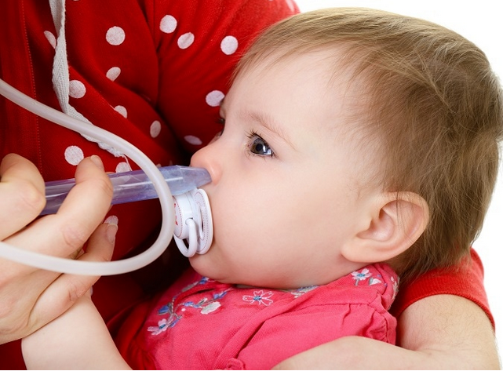
TITLE: BROCHURE ON HOW TO USE OF BULB SYRINGE ON BABIES  NAME:  INSTITUTION: |  |  | FEATURES, USES, AND IMPORTANCE OF BULB SYRINGE  A Bulb-Syringe is an effective, secure, and reliable home-care apparatus that each parent should acquire

- The profound features of a Bulb Syringe Aspirator include;-  - One or two pieces of bulbs  - Some bulb syringes are split to facilitate cleaning  - Consists of silicon or rubber component for easier disposal  - The bulb syringes are economical because they use cheap materials and available Over-The- Counter  - The bulb syringe aspirators have multiple uses as a home-care apparatus  Rubber Bulb Syringe Aspirator  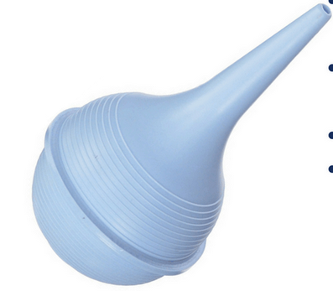  FACTORS TO CONSIDER WHEN TO SUCTION THE BABY’S TRACHEOSTOMY  -Suctioning the baby’s nose helps to remove mucus out of the infant nasal channel  -Several factors trigger a parent to suction mucus out of the nose, which include:-  - The baby experiences difficulties in breathing  - The infant is unable to feed and breast-feed properly  - The plug of mucus block the airway inside the tracheostomy  - When the heart beats faster than the normal pulse-rate  - The child is sweaty when it is cool  - When the child becomes inactive  - The skin color turns pale, bluish, or reddish  HoW TO USE BULB SYRINGE TO SUCTION THE NOSE OF A BABY Secondary Heading  - A Bulb Syringe is an easy-to-use apparatus that facilitates a mother to undertake a shallow, premeasured, and deep suctioning.  - Shallow Suctioning;  - -A shallow suctioning removes the mucus at the tip-end of the bulb syringe  - -Usually, a shallow suctioning is necessary after the child coughs  ADVANTAGES OF Bulb  IMPORTANT NOTES  - Always delegate one bulb syringe for a specific purpose to enhance the hygiene condition  - Only use deep suctioning during the emergencies procedures  - Set a maximum of four suctioning per day to prevent irritation of the nasal lining  - Use saline nose-drop solution to thin the mucus  - Suctioning is best undertaken before sleeping and sleeping time to prevent the child from vomiting  rEFERNCES  Cincinnati Children’s. (2016).Suctioning the nose with bulb syringe, Author. www.cincinnatichildrens.org/health/s/suction  Nationwide Children.org. (2018). Suctioning nose with a bulb syringe. Author. www.nationwidechildrens.org/family-resources-education/health-wellness-and-safety-resources  Morgan, D. (2009). How to suction your child’s tracheostomy, The Emily Center |  | FIRST:  *Wash your hands thoroughly using warm water and soap  SECOND:  *Squeeze the air out of the bulb using the thumb finger as shown below  Proper way to squeeze the Bulb  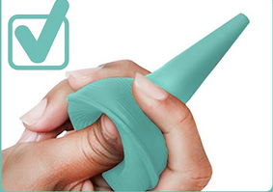  Improper way to squeeze the bulb  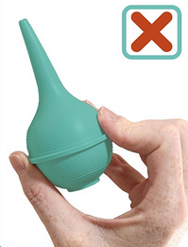  THIRD:  *Gently place the tip of the squeezed bulb into the nostril  FOURTH:  *Release the bulb to let the air suck back into the pressed area. The sucked air pulls out the mucus into the bulb syringe


FEATURES, USES, AND IMPORTANCE OF BULB SYRINGE



ADVANTAGES OF Bulb Syringe
- Price- the bulb syringe is relatively affordable compared to other techniques that include NoseFrida and Higginson Syringe. Besides, the bulb syringe does not require replacement components, which makes the item reusable
- Split Bulb- modern Bulb Syringes incorporate two components that are split to facilitate thorough cleaning
- Multiple Usage- a bulb syringe has multiple uses that including nasal aspirator, ear wax, and tracheostomy
- Ease to use- a bulb syringe involve one hand to operate, which allows the mother to comfort the child during the suctioning process
- Complete package- a bulb syringe is a single apparatus that does not require additional components.

dISADVANTAGES OF bULB Syringe
- The bulb syringe uses opaque elements that include silicon and rubber, which prevent the users to determine if they have suctioned enough mucus
- Lack of adequate airflow in the syringe can lead to manifestation of molds and other bacteria organisms
- Placing the tip-end of the syringe on the nostril causes irritation and discomfort

FIVE:
*Squeeze the mucus out of the Bulb Syringe onto a tissue paper

SIXTH:
*Repeat step 3 to 5 on the other nostril

SEVEN:
*Rinse the bulb syringe using warm and soapy water. This can be done by squeezing the bulb in the water, shake it thoroughly and release the water out of the tip-end

Summary of Shallow Suctioning Process
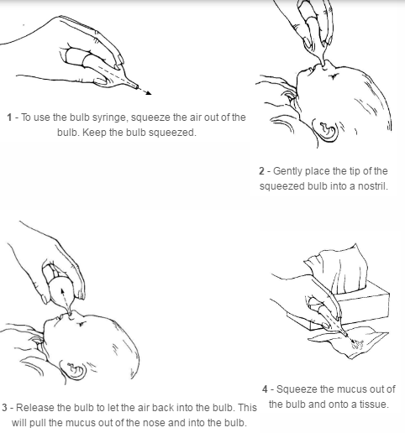

FEATURES, USES, AND IMPORTANCE OF BULB-SYRINGE

